NAME: HANAN MAJEED

COURSE:BSDS-02-A

CMS ID: 519166

FUNDAMENTAL OF COMPUTER PROGRAMMING

TASK 1:

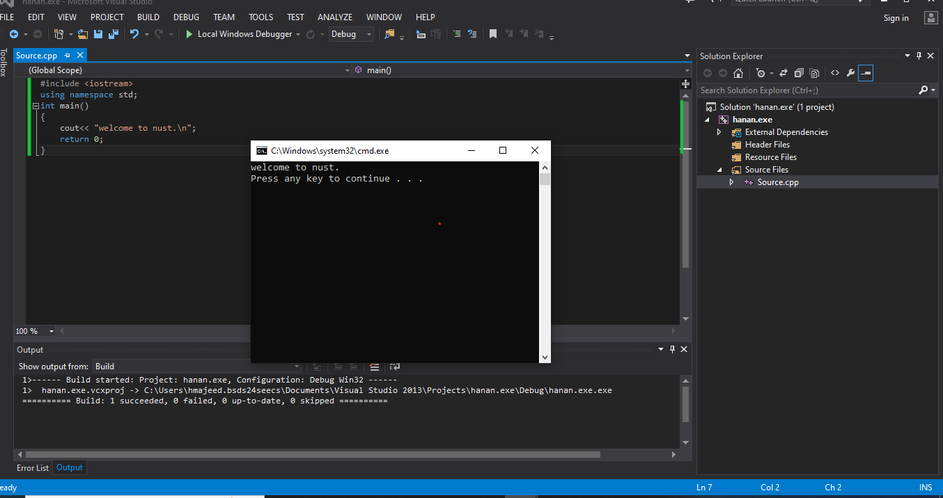

TASK 2 :

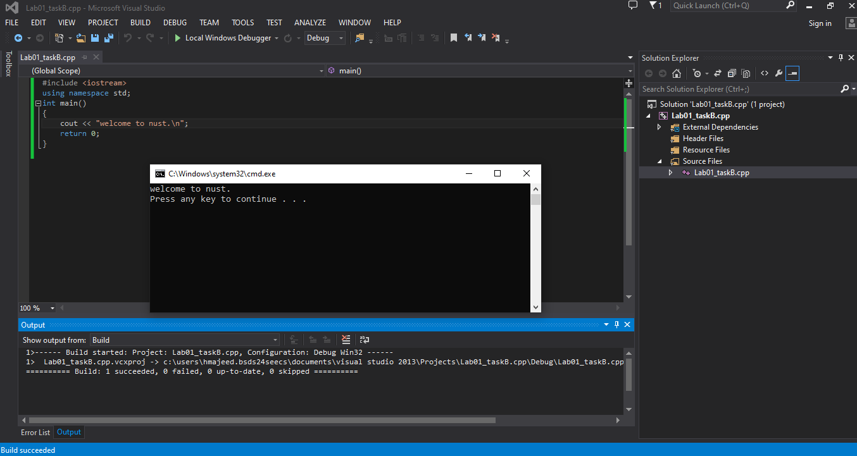

TASK 3:

First error:

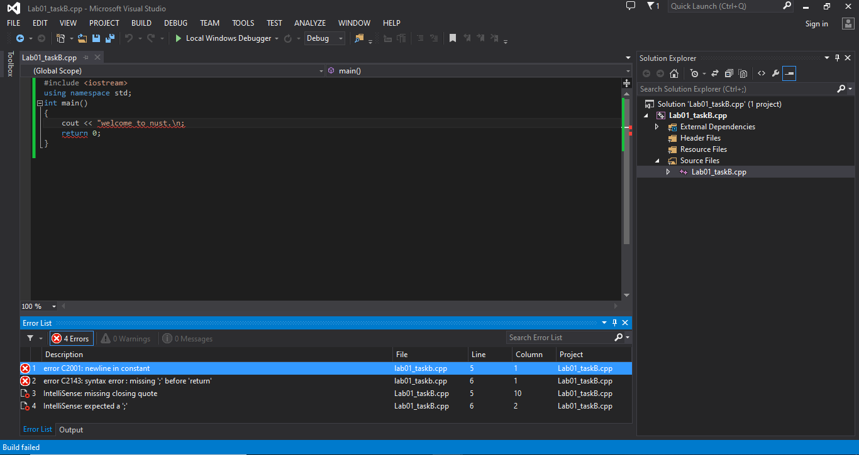

2nd error:

